MACHINE LEARINING

LAB ASSESSMENT – II

15BCE0082 VOLETI RAVI

**CODE:**

#! /usr/bin/python

import sys, re

from scipy.optimize.optimize import fmin_cg, fmin_bfgs, fmin

import numpy as np

import matplotlib.pyplot as plt

from numpy import loadtxt, where, zeros, e, array, log, ones, mean, where

from pylab import scatter, show, legend, xlabel, ylabel, plot

from scipy.optimize import fmin_bfgs

import math

def sigmoid(X):

g=1/(1+np.exp(-X))

return g

def costFunction(theta,X,y):

theta.shape = (1, 3)

m = y.size

h = sigmoid(X.dot(theta.conj().transpose()))

first = ((-y).T.dot(log(h)))

second = (1-y).T.dot(log(1-h))

J =(first - second)/m

return J.sum()

def gradFunction(theta,X,y):

theta.shape = (1, 3)

grad = zeros(3)

h = sigmoid(X.dot(theta.conj().transpose()))

delta = h - y

l = grad.size

for i in range(l):

sumdelta = delta.conj().transpose().dot(X[:, i])

grad[i] = (1.0 / m) * sumdelta * (-1)

theta.shape = (3,)

return grad

data = loadtxt('ex2data1.txt', delimiter=',')

X = data[:, 0:2]

y = data[:, 2]

pos = where(y == 1)

neg = where(y == 0)

scatter(X[pos, 0], X[pos, 1], marker='o', c='b')

scatter(X[neg, 0], X[neg, 1], marker='x', c='r')

xlabel('X')

ylabel('Y')

legend(['X', 'Y'])

m, n = X.shape

y.shape = (m, 1)

i = ones(shape=(m, 3))

i[:, 1:3] = X

def learning_parameters(i, y):

def f(theta):

return costFunction(theta, i, y)

def fprime(theta):

return gradFunction(theta, i, y)

theta = zeros(3)

return fmin_bfgs(f, theta, fprime, disp=True, maxiter=400)

learning_parameters(i, y)

theta = [-25.161272, 0.206233, 0.201470]

plot_x = array([min(i[:, 1]) - 2, max(i[:, 2]) + 2])

plot_y = (-1/theta[2]) * (theta[1] * plot_x + theta[0])

plot(plot_x, plot_y)

legend(['Decision', 'Admitted', 'Not-Admitted'])

show()

prob = sigmoid(array([1.0, 45.0, 85.0]).dot(array(theta).conj().transpose()))

print 'Probability: %f' % prob

def predict(theta,X):

m, n = X.shape

p = zeros(shape=(m, 1))

h = sigmoid(X.dot(theta.conj().transpose()))

for i in range(0, h.shape[0]):

if h[i] > 0.5:

p[i, 0] = 1

else:

p[i, 0] = 0

return p

p = predict(array(theta), i)

print "Train Accuracy:",((y[where(p == y)].size / float(y.size)) * 100.0)

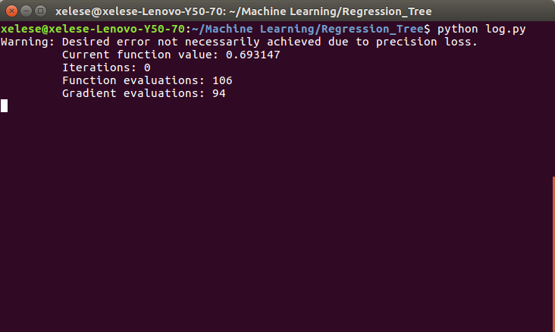**OUTPUT:**

